User Story 1
As a developer, I want AI to have awareness of my entire folder (repo) of code, so that I can ask AI for a repo summary or change code without needing to manually append context.

Development Specification 1:
Chat Log Links: P2-resubmission-chat-histories https://chatgpt.com/share/69024334-3824-8009-948c-9ef7c97b47f7

1. Header
Version: v2.0 (2025-10-27)
Authors:
- Christina Ma draft
- Baolin Shi
- Dejun Yang

2. Architecture Diagram
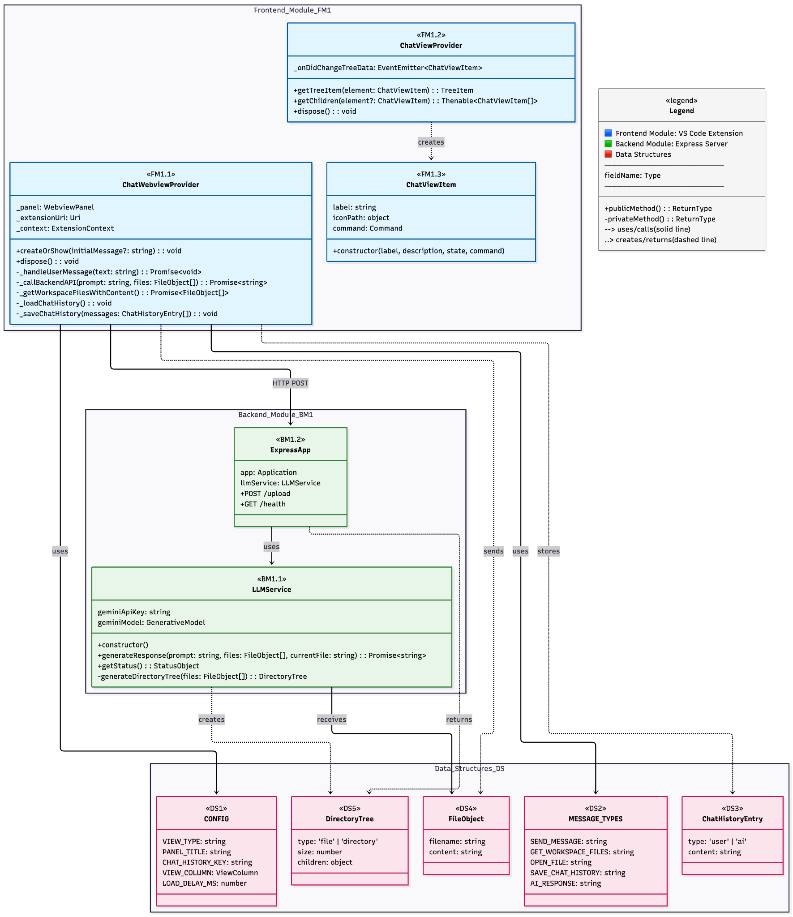
Rationale: We chose a clear module separation between frontend, backend, and data structures to mirror our actual code organization. The VS Code extension and Express backend naturally align with this modular view. The architecture diagram is simplified compared to the class diagram to show only the key methods.

3. Class Diagram
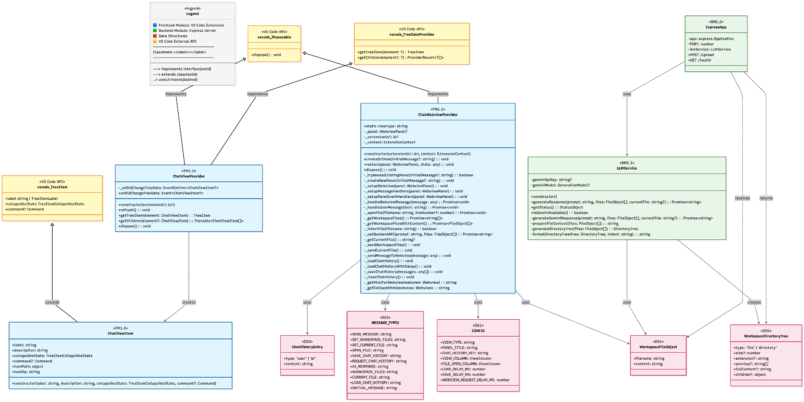
Rationale: The class diagram highlights all necessary classes and their corresponding attributes and methods, public or private. Highlighting the flow from ChatWebviewProvider to LLMService shows how user input travels through the system.

4. List of Classes

Frontend Module (FM1)
FM1.1 ChatWebviewProvider
Location: frontend/ai-chatbot-extension/src/chatWebviewProvider.ts
Purpose: Manages the VS Code webview panel for the AI Chatbot Assistant. Handles communication between the extension and the webview, chat history persistence, processes workspace files, and file navigation. Provides the main UI interface for user interaction with the AI assistant.
Implements: User Story 1 (Repo Awareness) - reads workspace files and provides context to AI, User Story 3 (Citations) - handles clickable file references and line navigation
Type: VS Code Extension Class (TypeScript)
FM1.2 ChatViewProvider
Location: frontend/ai-chatbot-extension/src/chatViewProvider.ts
Purpose: Provides tree view integration for the AI Assistant in VS Code sidebar. Manages the tree data structure and handles user interactions from the sidebar view.
Implements: User Story 123 - provides access to chat interface
Type: VS Code Tree Data Provider Class (TypeScript)
FM1.3 ChatViewItem
Location: frontend/ai-chatbot-extension/src/chatViewProvider.ts (lines 40-56)
Purpose: Represents individual items in the AI Assistant tree view. Provides visual representation and command handling for tree view elements.
Implements: User Story 123 - provides access to chat interface
Type: VS Code Tree Item Class (TypeScript)

Backend Module (BM1)
BM1.1 LLMService
Location: backend/services/llmService.js
Purpose: Core service that generates AI responses with citations using Google's Gemini API. Manages API initialization, response generation, file context preparation, and directory tree formatting. Handles file context preparation and citation generation with line numbers.
Implements: User Story 123 - generates file references with line numbers
Type: Service Class (JavaScript)
BM1.2 ExpressApp
Location: backend/index.js
Purpose: Express application instance that handles HTTP requests, routes, and middleware. Manages all API endpoints, including file uploads, health checks, directory tree generation, and error handling. Serves as the central HTTP server component.
Implements: User Story 123 - receives and processes entire repository files via /upload endpoint
Type: Express Application Instance (JavaScript)

Data Structures
DS1 CONFIG
Location: frontend/ai-chatbot-extension/src/chatWebviewProvider.ts (lines 11-20)
Purpose: Configuration constants for the AI Chatbot webview including view types, panel titles, timing delays, and column settings.
Type: Configuration Object (TypeScript const)
DS2 MESSAGE_TYPES
Location: frontend/ai-chatbot-extension/src/chatWebviewProvider.ts (lines 25-37)
Purpose: Message type constants for communication between webview and extension including send message, file operations, and chat history management.
Type: Message Type Constants (TypeScript const)
DS3 Chat History Entry
Location: frontend/ai-chatbot-extension/src/chatWebviewProvider.ts (messages array on lines 523, 546, and throughout)
Purpose: Data structure storing individual chat messages with type ('user' or 'ai') and content. Stored in VS Code global state with key 'ai-chatbot.chatHistory'. Array of message objects used for chat persistence.
Type: Chat Message Array (TypeScript interface)
DS4 Workspace File Object
Location: frontend/ai-chatbot-extension/src/chatWebviewProvider.ts (line 338, return type of _getWorkspaceFilesWithContent), backend/index.js (line 43, files array in request body) and throughout codebase
Purpose: Data structure representing a single file with structure {filename: string, content: string}. Used throughout the system for file representation - frontend sends as Array<{filename: string, content: string}> to backend, backend processes individual file objects. Used for AI processing, LLM context preparation, and API responses.
Type: File Payload Structure (TypeScript/JavaScript object)
DS5 Workspace Directory Tree
Location: backend/services/llmService.js (lines 135-176, generateDirectoryTree method)
Purpose: Recursive data structure representing file and directory hierarchy. For files: contains type ('file'), size, extension, preview (first 3 lines array), and fullContent. For directories: contains type ('directory') and children object. Used to represent repository structure for AI context and returned in API responses.
Type: Tree Data Structure (JavaScript object)
Rationale: We organized the list by module. We also kept file paths visible so we can quickly navigate to the relevant code and verify the classes.

5. State Diagram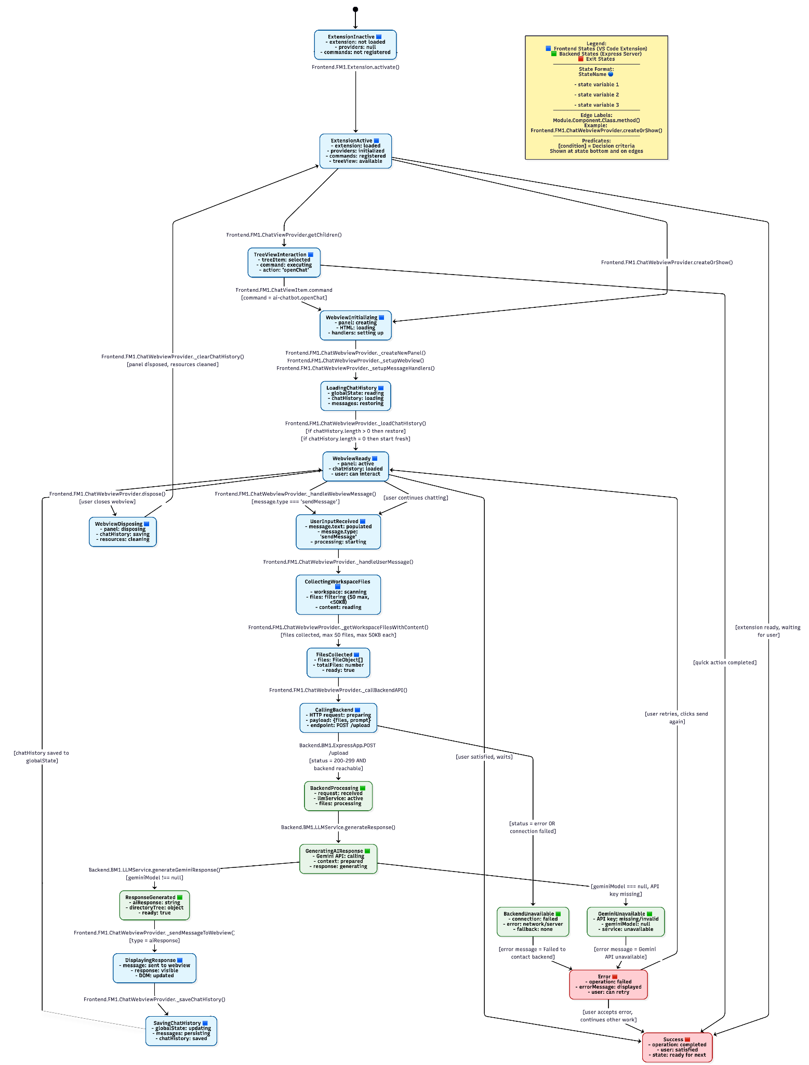
Rationale: Our state diagram captures the most important runtime transitions—activation, chat load, and request handling with a lot of error handling cases. Since it’s the state diagram for User Story 1, details for line citations (e.g., User Story 3) are omitted.

6. Flow Chart
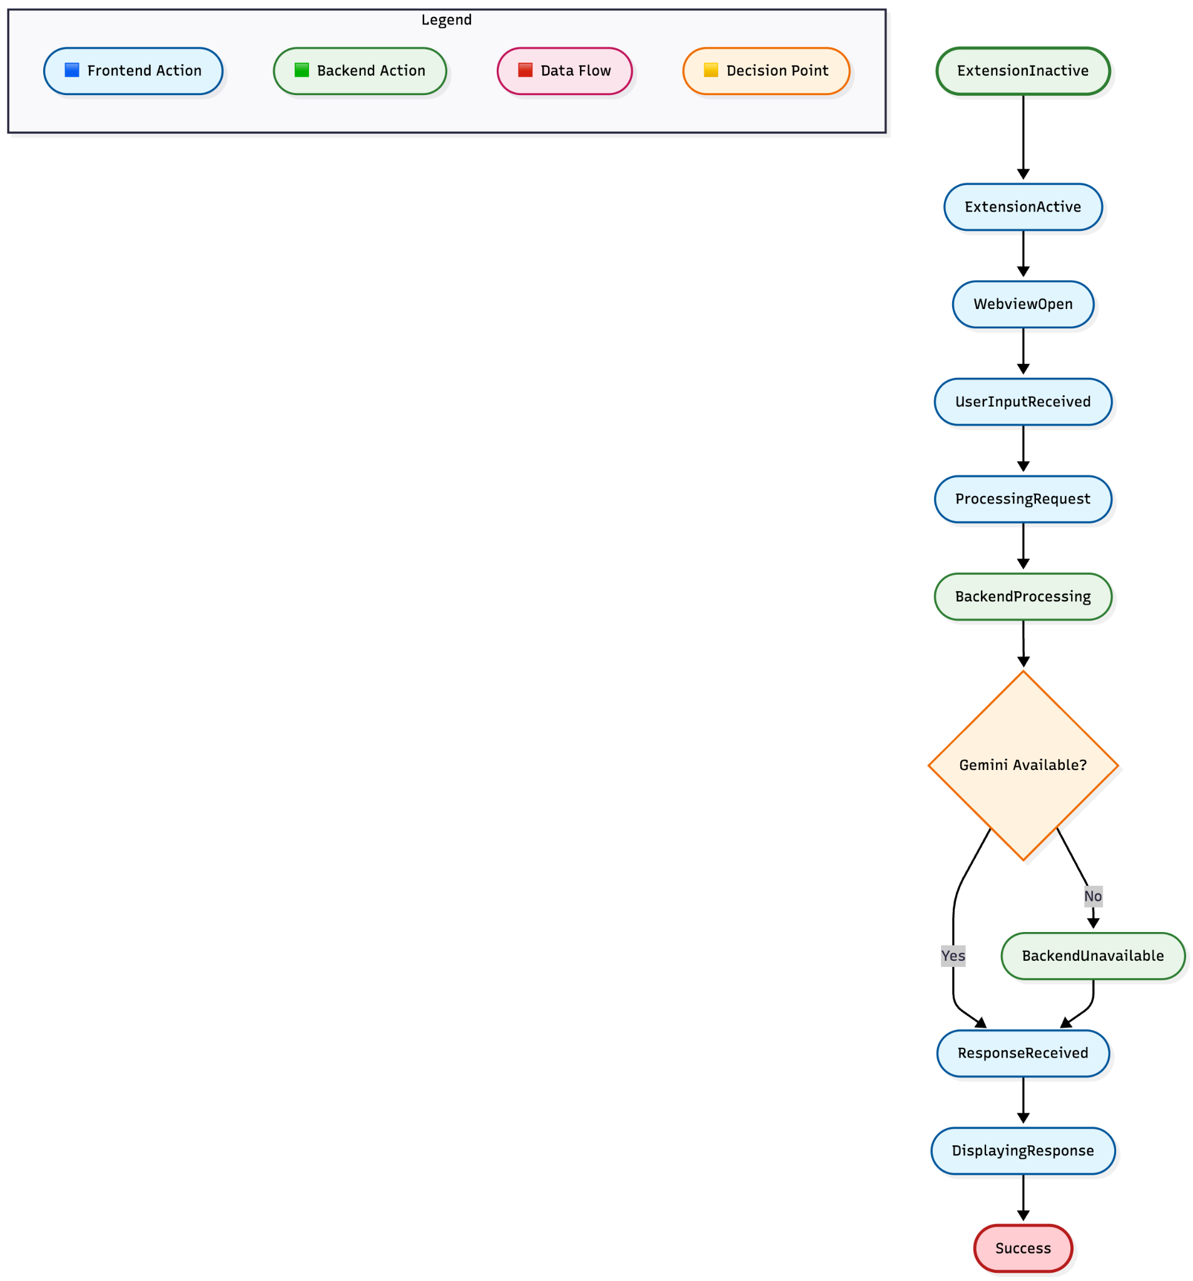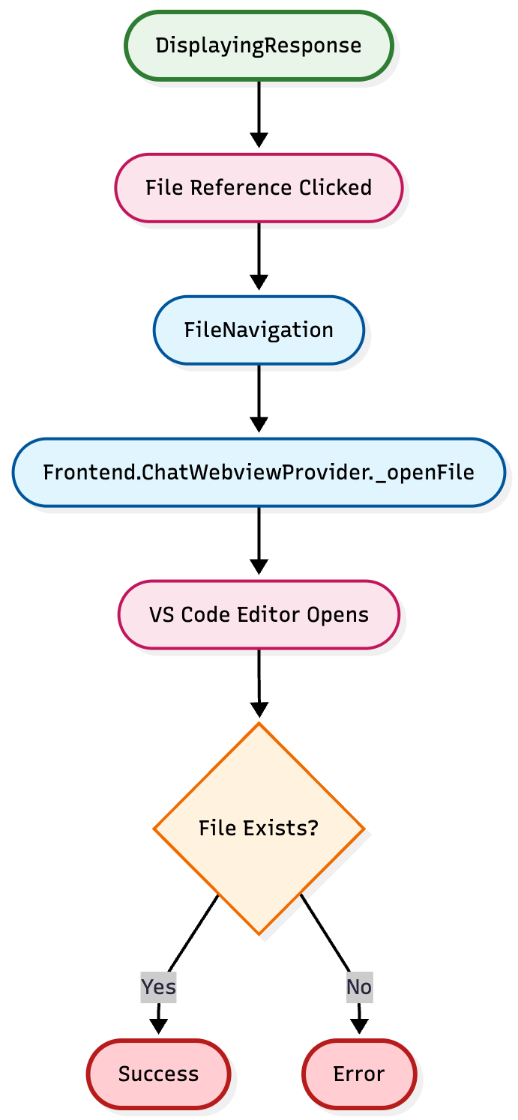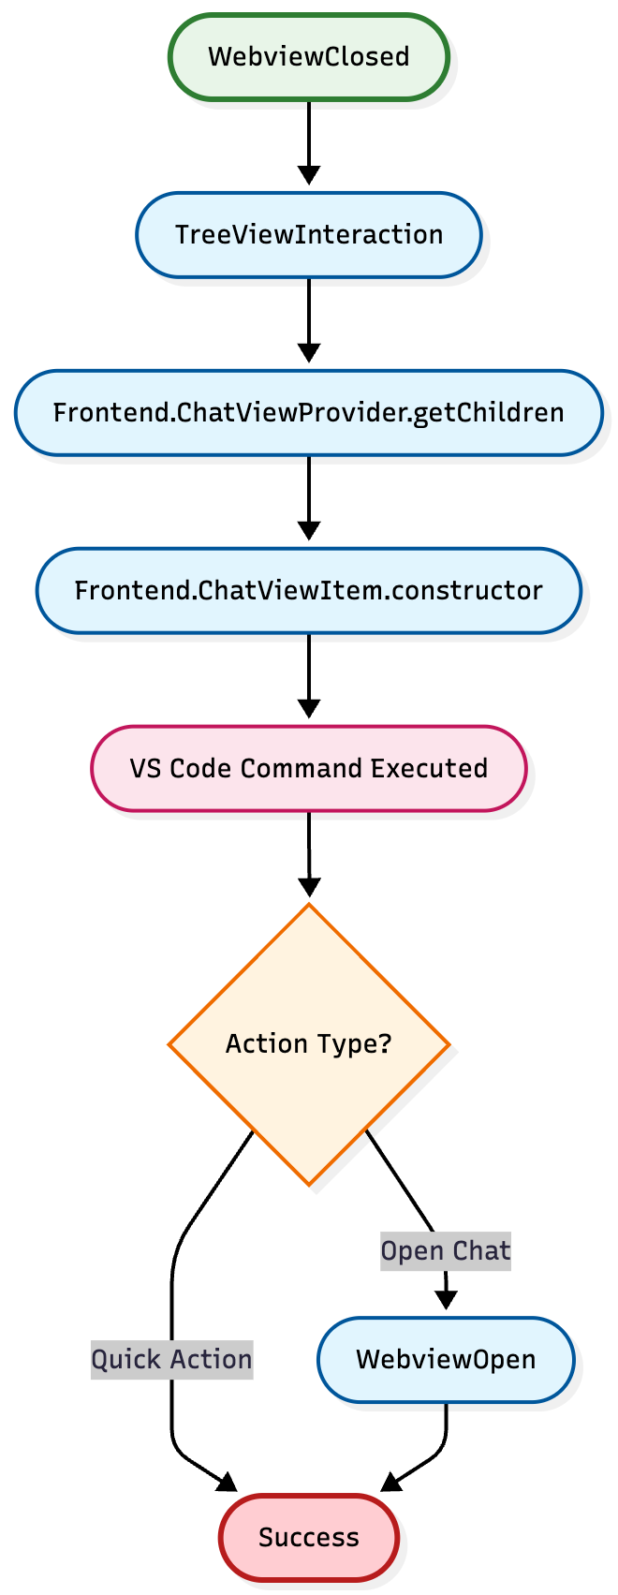
Rationale: The flow chart visually ties together how data and API calls move through the system from user action to AI output, starting from launching the extension to sending chat messages.

7. Development Risks and Failures
System Components Overview
- Frontend: VSCode Extension (TypeScript)
- Backend: Node.js Express Server (JavaScript)
- AI Service: Google Gemini API Integration
- Communication: HTTP/HTTPS API calls
- Storage: Local VSCode extension storage
Runtime Failures
F1: VSCode Extension Process Crash
- Likelihood: Medium | Impact: Medium
- User-visible effects: Chat interface becomes unavailable, extension commands stop working
- Internal effects: Webview panels close, message handlers become inactive
- Recovery procedure:
  - User restarts VSCode or reloads window (Ctrl+Shift+P → "Developer: Reload Window")
  - Extension automatically reactivates on VSCode startup
  - Chat history preserved in extension storage
F2: Backend Server Process Crash
- Likelihood: Medium | Impact: High
- User-visible effects: AI responses fail, upload requests timeout
- Internal effects: Express server stops, LLM service becomes unavailable
- Recovery procedure:
  - Automatic restart via PM2/process manager in production
  - Manual restart: npm start or node index.js
  - Health check endpoint monitoring
F3: Loss of Runtime State
- Likelihood: Low | Impact: Medium
- User-visible effects: Chat history lost, configuration reset
- Internal effects: Extension context cleared, webview state lost
- Recovery procedure:
  - Chat history persisted in VSCode extension storage
  - Configuration restored from VSCode settings
  - Webview recreated on next activation
F4: Extension Storage Corruption
- Likelihood: Low | Impact: Low
- User-visible effects: Chat history lost, user preferences reset
- Internal effects: VSCode extension global state becomes inaccessible
- Recovery procedure:
  - Clear extension storage: vscode.workspace.getConfiguration().update()
  - Reset to default settings
  - Rebuild chat history from scratch
F5: Unexpected State Transition
- Likelihood: Low | Impact: Medium
- User-visible effects: Extension behaves erratically, commands don't work
- Internal effects: Extension state becomes inconsistent
- Recovery procedure:
  - Extension deactivation and reactivation
  - Clear extension storage if needed
  - Restart VSCode as last resort
F6: Remote Procedure Call Failure (Gemini API)
- Likelihood: Medium | Impact: Medium
- User-visible effects: AI responses fail, fallback to mock responses
- Internal effects: API calls timeout or return errors
- Recovery procedure:
  - Automatic fallback to mock responses
  - Retry mechanism with exponential backoff
  - User notification of API unavailability
F7: Server Overload
- Likelihood: Medium | Impact: Medium
- User-visible effects: Slow responses, timeouts, degraded performance
- Internal effects: High CPU/memory usage, request queue buildup
- Recovery procedure:
  - Implement request rate limiting
  - Add request queuing and prioritization
  - Scale horizontally with load balancer
F8: Server Out of RAM
- Likelihood: Low | Impact: High
- User-visible effects: Server crashes, requests fail
- Internal effects: Node.js process killed by OS
- Recovery procedure:
  - Implement memory monitoring and alerts
  - Optimize file processing to reduce memory usage
  - Add memory limits and garbage collection tuning
Connectivity Failures
F9: Lost Network Connectivity
- Likelihood: Medium | Impact: High
- User-visible effects: Cannot connect to backend, AI features unavailable
- Internal effects: HTTP requests fail, extension falls back to offline mode
- Recovery procedure:
  - Implement offline mode with cached responses
  - Network connectivity detection and user notification
  - Automatic retry when connectivity restored
F10: Lost Extension Storage Access
- Likelihood: Low | Impact: Medium
- User-visible effects: Cannot save/load chat history, settings lost
- Internal effects: VSCode extension global state API failures
- Recovery procedure:
  - Fallback to in-memory storage
  - Periodic retry of storage operations
  - User notification of storage issues
F11: Network Traffic Spikes
- Likelihood: Medium | Impact: Medium
- User-visible effects: Slow responses, connection timeouts
- Internal effects: Bandwidth saturation, increased latency
- Recovery procedure:
  - Implement request throttling
  - Add CDN for static assets
  - Optimize payload sizes
F12: Lost Access to Gemini API
- Likelihood: Low | Impact: Medium
- User-visible effects: AI responses fail, fallback to mock responses
- Internal effects: API authentication failures, quota exceeded
- Recovery procedure:
  - Automatic fallback to mock responses
  - API key rotation and validation
  - Quota monitoring and alerts
Hardware Failures
F13: Server Down
- Likelihood: Low | Impact: High
- User-visible effects: Complete service unavailability
- Internal effects: All backend functionality lost
- Recovery procedure:
  - High availability setup with multiple servers
  - Health monitoring and automatic failover
  - Disaster recovery procedures
F14: Bad Configuration File
- Likelihood: Low | Impact: Medium
- User-visible effects: Server fails to start, incorrect behavior
- Internal effects: Environment variables corrupted, API keys invalid
- Recovery procedure:
  - Configuration validation on startup
  - Fallback to default configurations
  - Configuration backup and restore procedures
F15: Geographic/URI Migration
- Likelihood: Low | Impact: Medium
- User-visible effects: Service becomes unavailable at old location
- Internal effects: DNS changes, server relocation
- Recovery procedure:
  - DNS propagation and caching
  - Client-side URL configuration updates
  - Graceful migration with overlap period
Intruder Threats
F16: Denial of Service Attack
- Likelihood: Medium | Impact: High
- User-visible effects: Service unavailable, slow responses
- Internal effects: Server overwhelmed, resource exhaustion
- Recovery procedure:
  - Rate limiting and request throttling
  - DDoS protection services (Cloudflare)
  - Automatic scaling and load balancing
F17: System Intrusion - OS Trash
- Likelihood: Low | Impact: Critical
- User-visible effects: Complete system compromise
- Internal effects: Server files deleted, system unusable
- Recovery procedure:
  - Regular system backups and snapshots
  - Immutable infrastructure deployment
  - Incident response and recovery procedures
F18: Code Injection/Modification
- Likelihood: Low | Impact: Critical
- User-visible effects: Malicious behavior, data theft
- Internal effects: Source code compromised, backdoors installed
- Recovery procedure:
  - Code integrity monitoring
  - Secure deployment pipelines
  - Regular security audits and code reviews
F19: Extension Storage Breach
- Likelihood: Low | Impact: Critical
- User-visible effects: User data exposed, privacy violations
- Internal effects: VSCode extension global state compromised
- Recovery procedure:
  - Data encryption at rest and in transit
  - Access logging and monitoring
  - Incident response and notification procedures
F20: Bot Spam/Abuse
- Likelihood: Medium | Impact: Medium
- User-visible effects: Degraded performance, resource waste
- Internal effects: API quota exhaustion, server overload
- Recovery procedure:
  - Rate limiting and user authentication
  - CAPTCHA and bot detection
  - Usage monitoring and abuse prevention
F21: HTTP Session Hijacking
- Likelihood: Low | Impact: High
- User-visible effects: Unauthorized access to user sessions
- Internal effects: User impersonation, data access
- Recovery procedure:
  - HTTPS enforcement and secure cookies
  - Session token rotation and validation
  - User notification of suspicious activity
Failure Mode | Description | Likelihood | Impact | Priority
F17 | System Intrusion - OS Trash | Low | Critical | High
F18 | Code Injection/Modification | Low | Critical | High
F19 | Extension Storage Breach | Low | Critical | High
F2 | Backend Server Process Crash | Medium | High | High
F9 | Lost Network Connectivity | Medium | High | High
F16 | Denial of Service Attack | Medium | High | High
F8 | Server Out of RAM | Low | High | Medium
F13 | Server Down | Low | High | Medium
F21 | HTTP Session Hijacking | Low | High | Medium
F1 | VSCode Extension Process Crash | Medium | Medium | Medium
F6 | Remote Procedure Call Failure (Gemini API) | Medium | Medium | Medium
F7 | Server Overload | Medium | Medium | Medium
F11 | Network Traffic Spikes | Medium | Medium | Medium
F20 | Bot Spam/Abuse | Medium | Medium | Medium
F3 | Loss of Runtime State | Low | Medium | Low
F5 | Unexpected State Transition | Low | Medium | Low
F10 | Lost Extension Storage Access | Low | Medium | Low
F12 | Lost Access to Gemini API | Low | Medium | Low
F14 | Bad Configuration File | Low | Medium | Low
F15 | Geographic/URI Migration | Low | Medium | Low
F4 | Extension Storage Corruption | Low | Low | Low

Rationale: This section identifies possible failure modes and recovery procedures to mitigate downtime. We categorize risks by likelihood and impact, so we can prioritize preventive measures.

8. Technology Stack
Total Technologies: 16
- Backend Technologies: 8 (T1-T8)
- Frontend Technologies: 8 (T9-T16)
- Production Dependencies: 8 (T1-T5, T9-T11)
- Development Dependencies: 8 (T6, T12-T15, T7-T8, T16)
Architecture: VS Code Extension with separate backend API server Language: TypeScript (frontend) + JavaScript (backend) Runtime: Node.js v16+ AI Integration: Google Gemini via official SDK
Backend Technologies
T1: Node.js (v16.x or higher)
- Purpose: JavaScript runtime environment for backend server
- Why chosen: Industry standard for JavaScript server applications, excellent npm ecosystem
- Source: https://nodejs.org/
- Documentation: https://nodejs.org/docs/
- Version: >=16.0.0 (as specified in package.json engines)
T2: Express.js (v4.18.2)
- Purpose: Web framework for handling HTTP requests and routing
- Why chosen: Most popular Node.js web framework, simple and flexible
- Source: https://www.npmjs.com/package/express
- Documentation: https://expressjs.com/
- Version: ^4.18.2
T3: Google Generative AI SDK (@google/generative-ai v0.24.1)
- Purpose: Integration with Gemini AI for generating summaries and citations
- Why chosen: Official Google SDK for Gemini, provides type-safe API access
- Source: https://www.npmjs.com/package/@google/generative-ai
- Documentation: https://ai.google.dev/docs
- Version: ^0.24.1
T4: CORS (v2.8.5)
- Purpose: Enable Cross-Origin Resource Sharing for frontend-backend communication
- Why chosen: Essential for allowing frontend applications to communicate with backend API, standard middleware for Express
- Source: https://www.npmjs.com/package/cors
- Documentation: https://github.com/expressjs/cors
- Version: ^2.8.5
T5: dotenv (v16.3.1)
- Purpose: Load environment variables from .env file
- Why chosen: Standard tool for managing configuration and API keys securely
- Source: https://www.npmjs.com/package/dotenv
- Documentation: https://github.com/motdotla/dotenv
- Version: ^16.3.1
T6: Nodemon (v3.0.1) - Dev Dependency
- Purpose: Auto-restart server on file changes during development
- Why chosen: Improves developer experience by eliminating manual server restarts
- Source: https://www.npmjs.com/package/nodemon
- Documentation: https://nodemon.io/
- Version: ^3.0.1
T7: Built-in Node.js Modules
- Purpose: Core Node.js functionality (http, https, url, fs, path, assert)
- Why chosen: Part of Node.js runtime, no additional dependencies needed
- Source: https://nodejs.org/api/
- Documentation: https://nodejs.org/api/
- Version: Included with Node.js v16+
T8: Bash Shell Scripting
- Purpose: Deployment automation (deploy.sh)
- Why chosen: Standard Unix/Linux scripting for deployment tasks
- Source: Built into Unix/Linux systems
- Documentation: https://www.gnu.org/software/bash/manual/
- Version: System dependent
Frontend Technologies (VS Code Extension)
T9: VS Code Extension API (@types/vscode v1.82.0)
- Purpose: Core API for VS Code extension development
- Why chosen: Required for building VS Code extensions, provides type definitions
- Source: https://www.npmjs.com/package/@types/vscode
- Documentation: https://code.visualstudio.com/api
- Version: ^1.82.0
T10: TypeScript (v4.9.4)
- Purpose: Type-safe JavaScript development for VS Code extension
- Why chosen: Catches errors at compile time, improves code maintainability
- Source: https://www.npmjs.com/package/typescript
- Documentation: https://www.typescriptlang.org/
- Version: ^4.9.4
T11: Axios (v1.6.0)
- Purpose: HTTP client for making API requests from frontend to backend
- Why chosen: Promise-based HTTP client, better than fetch for complex requests
- Source: https://www.npmjs.com/package/axios
- Documentation: https://axios-http.com/docs/intro
- Version: ^1.6.0
T12: ESLint (v8.28.0) - Dev Dependency
- Purpose: JavaScript/TypeScript linting tool
- Why chosen: Industry standard for code quality and consistency
- Source: https://www.npmjs.com/package/eslint
- Documentation: https://eslint.org/docs/latest/
- Version: ^8.28.0
T13: TypeScript ESLint Parser (@typescript-eslint/parser v5.45.0) - Dev Dependency
- Purpose: ESLint parser for TypeScript files
- Why chosen: Required for ESLint to parse TypeScript syntax
- Source: https://www.npmjs.com/package/@typescript-eslint/parser
- Documentation: https://typescript-eslint.io/
- Version: ^5.45.0
T14: TypeScript ESLint Plugin (@typescript-eslint/eslint-plugin v5.45.0) - Dev Dependency
- Purpose: ESLint rules for TypeScript
- Why chosen: Provides TypeScript-specific linting rules
- Source: https://www.npmjs.com/package/@typescript-eslint/eslint-plugin
- Documentation: https://typescript-eslint.io/
- Version: ^5.45.0
T15: @types/node (v16.x) - Dev Dependency
- Purpose: TypeScript type definitions for Node.js
- Why chosen: Provides type safety for Node.js APIs
- Source: https://www.npmjs.com/package/@types/node
- Documentation: https://github.com/DefinitelyTyped/DefinitelyTyped
- Version: 16.x
T16: Built-in Node.js Modules (Frontend)
- Purpose: Core Node.js functionality (path, fs, https, http, url)
- Why chosen: Part of Node.js runtime, no additional dependencies needed
- Source: https://nodejs.org/api/
- Documentation: https://nodejs.org/api/
- Version: Included with Node.js v16+
Rationale: Since we are developing a VSCode Extension, our tech stack uses TypeScript and Node.js, which were natural fits for both the frontend and backend. We check against package. Json and package-lock.json to verify the tech stack.

9. APIs

BM1.1 - LLMService (AI Response Generation Service)
Location: backend/services/llmService.js
Purpose: Generates AI responses using Google Gemini API with file context
Public Methods
BM1.1.1 constructor()
Parameters: None
Returns: LLMService
Purpose: Initializes LLMService with Gemini API key from environment
Used by: BM1.2 Express app initialization
BM1.1.2 generateResponse(prompt, files, currentFile = null)
Parameters:
- prompt: string - User's question/prompt
- files: FileObject[] - Array of file objects with filename and content
- currentFile: string | null - Currently open file (optional)
Returns: Promise<string> - AI generated response
Purpose: Main entry point for generating AI responses
Used by: BM1.2 POST /upload endpoint
BM1.1.3 getStatus()
Parameters: None
Returns: {geminiAvailable: boolean, geminiApiKey: boolean, service: string}
Purpose: Returns current status of LLM service
Used by: BM1.2 GET /health endpoint
BM1.1.4 isGeminiAvailable()
Parameters: None
Returns: boolean
Purpose: Checks if Gemini model is initialized and available
Used by: Internal status checks, BM1.1.3 getStatus
Private Methods
BM1.1.5 generateGeminiResponse(prompt, files, currentFile = null)
Parameters:
- prompt: string - User's question/prompt
- files: FileObject[] - Array of file objects
- currentFile: string | null - Currently open file
Returns: Promise<string> - Gemini API response
Purpose: Generates response using Gemini API with prepared context
Used by: BM1.1.2 generateResponse
BM1.1.6 prepareFileContext(files)
Parameters:
- files: FileObject[] - Array of file objects
Returns: string - Formatted file context (first 10 lines per file)
Purpose: Prepares file content preview for LLM context
Used by: BM1.1.5 generateGeminiResponse
BM1.1.7 generateDirectoryTree(files)
Parameters:
- files: FileObject[] - Array of file objects
Returns: object - Nested tree structure {[key]: {type, size, extension, preview, fullContent} | {type, children}}
Purpose: Generates hierarchical directory tree from flat file list
Used by: BM1.1.5 generateGeminiResponse, BM1.2 POST /upload endpoint
BM1.1.8 formatDirectoryTree(tree, indent = '')
Parameters:
- tree: object - Directory tree structure
- indent: string - Indentation string (default: '')
Returns: string - Formatted text representation with emoji icons
Purpose: Formats tree structure as human-readable text with file previews
Used by: BM1.1.5 generateGeminiResponse

BM1.2 - ExpressApp (HTTP Server)
Location: backend/index.js
Purpose: HTTP server handling file uploads and AI response generation requests
Public HTTP Endpoints
BM1.2.1 POST /upload
Parameters (Request Body):
{
"files": FileObject[], // Array of {filename: string, content: string}
"prompt": string // User's question
}

Returns (Response):
{
"message": string, // Status message
"aiResponse": string, // AI generated response
"directoryTree": object, // Hierarchical file structure
"llmStatus": object, // LLM service status
"metadata": {
"filesProcessed": number,
"totalCharacters": number,
"timestamp": string
}
}

Purpose: Main endpoint for processing file uploads and generating AI responses
Used by: FM1.1 ChatWebviewProvider._callBackendAPI
BM1.2.2 GET /health
Parameters: None
Returns:
{
"status": string, // "healthy"
"timestamp": string, // ISO timestamp
"uptime": number, // Process uptime in seconds
"llmStatus": object // From BM1.1.3 getStatus()
}

Purpose: Health check endpoint for monitoring
Used by: Monitoring systems, health checks
Middleware (Internal)
BM1.2.3 CORS Middleware
Purpose: Enables cross-origin requests (all origins in development)
Applied to: All routes
BM1.2.4 Body Parser Middleware
Purpose: Parses JSON/URL-encoded bodies (10MB limit)
Applied to: All routes
BM1.2.5 Request Logger Middleware
Purpose: Logs all incoming requests with timestamp
Applied to: All routes
BM1.2.6 Error Handler Middleware
Purpose: Catches and formats error responses
Applied to: All routes
BM1.2.7 404 Handler
Purpose: Returns 404 for unknown endpoints
Applied to: All unmatched routes

FM1.1 - ChatWebviewProvider (Webview Manager)
Location: frontend/ai-chatbot-extension/src/chatWebviewProvider.ts
Purpose: Manages VS Code webview panel for AI chat interface
Public Methods
FM1.1.1 constructor(extensionUri, context)
Parameters:
- extensionUri: vscode.Uri - Extension root URI
- context: vscode.ExtensionContext - VS Code extension context
Returns: ChatWebviewProvider
Purpose: Initializes webview provider
Used by: Extension activation (extension.ts)
FM1.1.2 createOrShow(initialMessage?)
Parameters:
- initialMessage?: string - Optional initial message to display
Returns: void
Purpose: Creates new webview panel or reveals existing one
Used by: Extension commands (ai-chatbot.openChat, ai-chatbot.openChatInEditor)
FM1.1.3 restore(panel, state)
Parameters:
- panel: vscode.WebviewPanel - Webview panel to restore
- state: any - Serialized state (unused)
Returns: void
Purpose: Restores webview from serialized state after VS Code restart
Used by: VS Code webview serializer
FM1.1.4 dispose()
Parameters: None
Returns: void
Purpose: Disposes webview and cleans up resources
Used by: Extension deactivation
Private Methods (Webview Management)
FM1.1.5 _tryRevealExistingPanel(initialMessage?)
Parameters:
- initialMessage?: string - Optional message
Returns: boolean - true if panel was revealed, false if new panel needed
Purpose: Attempts to reveal existing panel instead of creating new one
Used by: FM1.1.2 createOrShow
FM1.1.6 _createNewPanel(initialMessage?)
Parameters:
- initialMessage?: string - Optional message
Returns: void
Purpose: Creates new webview panel with configuration
Used by: FM1.1.2 createOrShow
FM1.1.7 _setupWebview(panel)
Parameters:
- panel: vscode.WebviewPanel
Returns: void
Purpose: Sets up webview HTML content
Used by: FM1.1.6 _createNewPanel, FM1.1.3 restore
FM1.1.8 _setupMessageHandlers(panel)
Parameters:
- panel: vscode.WebviewPanel
Returns: void
Purpose: Registers message handlers for webview communication
Used by: FM1.1.6 _createNewPanel, FM1.1.3 restore
FM1.1.9 _setupPanelEventHandlers(panel)
Parameters:
- panel: vscode.WebviewPanel
Returns: void
Purpose: Registers panel lifecycle event handlers
Used by: FM1.1.6 _createNewPanel
Private Methods (Message Handling)
FM1.1.10 _handleWebviewMessage(message)
Parameters:
- message: any - Message from webview with type and data
Returns: Promise<void>
Purpose: Routes messages from webview to appropriate handlers
Used by: FM1.1.8 message handler registration
FM1.1.11 _handleUserMessage(text)
Parameters:
- text: string - User's chat message
Returns: Promise<void>
Purpose: Processes user message and generates AI response
Used by: FM1.1.10 _handleWebviewMessage
FM1.1.12 _sendMessageToWebview(message)
Parameters:
- message: any - Message object with type and data
Returns: void
Purpose: Sends message to webview
Used by: Multiple methods for webview communication
Private Methods (File Operations)
FM1.1.13 _openFile(fileName, lineNumber?)
Parameters:
- fileName: string - File name or path
- lineNumber?: number - Optional line number to navigate to
Returns: Promise<void>
Purpose: Opens file in editor at specific line
Used by: FM1.1.10 _handleWebviewMessage (OPEN_FILE message)
FM1.1.14 _getWorkspaceFiles()
Parameters: None
Returns: Promise<string[]> - Array of relative file paths (max 100)
Purpose: Gets list of workspace files (excluding node_modules)
Used by: FM1.1.19 _sendWorkspaceFiles, FM1.1.13 _openFile
FM1.1.15 _getWorkspaceFilesWithContent()
Parameters: None
Returns: Promise<Array<{filename: string, content: string}>> - Array of files with content (max 50 files, <50KB each)
Purpose: Gets workspace files with content for backend API
Used by: FM1.1.11 _handleUserMessage
FM1.1.16 _isTextFile(filename)
Parameters:
- filename: string - File name to check
Returns: boolean
Purpose: Checks if file is text-based by extension
Used by: FM1.1.15 _getWorkspaceFilesWithContent
FM1.1.17 _getCurrentFile()
Parameters: None
Returns: string | undefined - Currently active file path
Purpose: Gets currently open file in editor
Used by: FM1.1.20 _sendCurrentFile
FM1.1.18 _sendWorkspaceFiles()
Parameters: None
Returns: void
Purpose: Sends workspace file list to webview
Used by: FM1.1.10 _handleWebviewMessage (GET_WORKSPACE_FILES message)
FM1.1.19 _sendCurrentFile()
Parameters: None
Returns: void
Purpose: Sends current file info to webview
Used by: FM1.1.10 _handleWebviewMessage (GET_CURRENT_FILE message)
Private Methods (Backend Communication)
FM1.1.20 _callBackendAPI(prompt, files)
Parameters:
- prompt: string - User's question
- files: Array<{filename: string, content: string}> - Workspace files
Returns: Promise<string> - AI response from backend
Purpose: Calls BM1.2 POST /upload endpoint
Used by: FM1.1.11 _handleUserMessage
Private Methods (Chat History)
FM1.1.21 _loadChatHistory()
Parameters: None
Returns: void
Purpose: Loads chat history from VS Code global state
Used by: FM1.1.22 _loadChatHistoryWithDelay, FM1.1.9 panel event handlers
FM1.1.22 _loadChatHistoryWithDelay()
Parameters: None
Returns: void
Purpose: Loads chat history after delay to ensure webview is ready
Used by: FM1.1.6 _createNewPanel, FM1.1.3 restore
FM1.1.23 _saveChatHistory(messages)
Parameters:
- messages: any[] - Array of chat messages with type and content
Returns: void
Purpose: Saves chat history to VS Code global state
Used by: FM1.1.10 _handleWebviewMessage (SAVE_CHAT_HISTORY message)
FM1.1.24 _clearChatHistory()
Parameters: None
Returns: void
Purpose: Clears chat history from storage
Used by: FM1.1.6 _createNewPanel
Private Methods (HTML Generation)
FM1.1.25 _getHtmlForWebview(webview)
Parameters:
- webview: vscode.Webview - Webview instance
Returns: string - HTML content
Purpose: Generates HTML for webview (tries React app, falls back to embedded HTML)
Used by: FM1.1.7 _setupWebview
FM1.1.26 _getFallbackHtml(webview)
Parameters:
- webview: vscode.Webview - Webview instance
Returns: string - Fallback HTML content
Purpose: Generates embedded HTML when React app unavailable
Used by: FM1.1.25 _getHtmlForWebview

FM1.2 - ChatViewProvider (Sidebar Tree View)
Location: frontend/ai-chatbot-extension/src/chatViewProvider.ts
Purpose: Provides tree view in VS Code sidebar activity bar
Public Methods
FM1.2.1 constructor(extensionUri)
Parameters:
- extensionUri: vscode.Uri - Extension root URI
Returns: ChatViewProvider
Purpose: Initializes tree view provider
Used by: Extension activation
FM1.2.2 refresh()
Parameters: None
Returns: void
Purpose: Triggers tree view refresh
Used by: External callers to update tree view
FM1.2.3 getTreeItem(element)
Parameters:
- element: ChatViewItem - Tree item to render
Returns: vscode.TreeItem
Purpose: Returns tree item for VS Code to render
Used by: VS Code tree view system
FM1.2.4 getChildren(element?)
Parameters:
- element?: ChatViewItem - Parent element (optional)
Returns: Thenable<ChatViewItem[]> - Array of child items
Purpose: Returns children for tree view hierarchy
Used by: VS Code tree view system
FM1.2.5 dispose()
Parameters: None
Returns: void
Purpose: Disposes event emitter
Used by: Extension deactivation
Public Properties
FM1.2.6 onDidChangeTreeData
Type: vscode.Event<ChatViewItem | undefined | null | void> (readonly)
Purpose: Event fired when tree data changes
Used by: VS Code tree view system

FM1.3 - ChatViewItem (Tree Item)
Location: frontend/ai-chatbot-extension/src/chatViewProvider.ts
Purpose: Represents individual item in tree view
Public Methods
FM1.3.1 constructor(label, description, collapsibleState, command?)
Parameters:
- label: string - Item label text
- description: string - Item description
- collapsibleState: vscode.TreeItemCollapsibleState - Collapse state
- command?: vscode.Command - Optional command to execute on click
Returns: ChatViewItem
Purpose: Creates tree item
Used by: FM1.2.4 getChildren
Public Properties
FM1.3.2 label
Type: string (readonly)
Purpose: Item display label
FM1.3.3 collapsibleState
Type: vscode.TreeItemCollapsibleState (readonly)
Purpose: Whether item is collapsible
FM1.3.4 command
Type: vscode.Command (readonly, optional)
Purpose: Command executed when item clicked
FM1.3.5 iconPath
Type: {light: vscode.Uri, dark: vscode.Uri}
Purpose: Icon paths for light/dark themes
FM1.3.6 tooltip
Type: string
Purpose: Tooltip text on hover
FM1.3.7 description
Type: string
Purpose: Secondary description text

Rationale: We use only two main endpoints (/upload and /health), which keeps integration simple and reduces maintenance. Each frontend and backend module’s APIs (public and private) are listed separately for ease of verification.

10. Public Interfaces

Within Frontend Module (FM1)
FM1.1 uses FM1.2:
- None (no direct usage)
FM1.2 uses FM1.1:
- None (no direct usage)
FM1.2 uses FM1.3:
- FM1.2.4 getChildren() → creates FM1.3.1 constructor()
- FM1.2.3 getTreeItem() → receives FM1.3 instances

Within Backend Module (BM1)
BM1.2 uses BM1.1:
- BM1.2.1 POST /upload → calls BM1.1.2 generateResponse()
- BM1.2.1 POST /upload → calls BM1.1.7 generateDirectoryTree()
- BM1.2.2 GET /health → calls BM1.1.3 getStatus()

Cross-Module (Frontend → Backend)
FM1.1 uses BM1.2:
- FM1.1.20 _callBackendAPI() → HTTP POST to BM1.2.1 /upload
  - Sends: {files: FileObject[], prompt: string}
  - Receives: {aiResponse: string, directoryTree: object, ...}

External Dependencies
FM1 (Frontend) uses VS Code API:
- vscode.window - Window management, text editors
- vscode.workspace - Workspace file access
- vscode.Webview - Webview panel management
- vscode.TreeDataProvider - Tree view integration
- vscode.ExtensionContext - Extension context and storage
BM1 (Backend) uses Node.js Libraries:
- express - HTTP server framework
- cors - Cross-origin resource sharing
- @google/generative-ai - Gemini API client

Rationale: We keep the public interfaces consistent across user stories. The clean separation between frontend and backend interfaces supports independent testing and readability.

11. Data Schemas
We do not maintain a database storage for our extension.

12. Security & Privacy
PII Temporarily Stored
1. API Keys and Tokens
- Data: Gemini API keys, VSCode extension tokens
- Justification: Required for AI service authentication and extension functionality
- Source: User configuration, environment variables
- Flow: User input → Extension settings → Backend service → Gemini API
- Usage: Authentication, API calls, service access
- Disposal: Cleared from memory after use, not persisted
- Protection: Environment variables, secure storage, HTTPS transmission
2. Code Content
- Data: User's source code files, project structure
- Justification: Required for AI analysis and code assistance
- Source: User's workspace files
- Flow: VSCode workspace → Extension → Backend → Gemini API
- Usage: AI analysis, code understanding, response generation
- Disposal: Not persisted, cleared after processing
- Protection: HTTPS transmission, temporary processing only
3. Chat Messages
- Data: User queries, AI responses
- Justification: Required for conversation context and history
- Source: User input via extension interface
- Flow: Extension → Backend → AI service → Extension storage
- Usage: Conversation history, context maintenance
- Disposal: Stored locally in VSCode extension storage
- Protection: Local storage only, encrypted if possible
PII Long-term Storage
1. Chat History
- Data: Conversation logs, user queries, AI responses
- Justification: User experience, conversation continuity
- Storage: VSCode extension global state (context.globalState)
- Entry: User interactions with extension
- Pre-storage Flow: Extension → VSCode global state
- Post-storage Flow: VSCode global state → Extension display
- Responsibility: Extension developer, VSCode platform
- Audit: VSCode extension storage logs
2. Extension Settings
- Data: User preferences, API keys, configuration
- Justification: User customization, service configuration
- Storage: VSCode settings storage
- Entry: User configuration via VSCode settings
- Pre-storage Flow: Settings UI → VSCode settings
- Post-storage Flow: VSCode settings → Extension configuration
- Responsibility: Extension developer, VSCode platform
- Audit: VSCode settings access logs
Security Responsibilities
Data Storage Security
- Extension Storage: VSCode platform security model
- Backend Storage: Developer responsibility (minimal data stored)
- API Keys: User responsibility for secure storage
Privacy Policy
Customer-Visible Privacy Policy
- Location: Extension marketplace listing, README file
- Acceptance: Implicit through extension installation
- Content:
  - Data collection practices
  - Third-party service usage (Gemini API)
  - Data retention policies
  - User rights and controls
Access Control Policies
- Temporary Access: Session-based, cleared after use
- Long-term Access: User-controlled through VSCode settings
- Administrative Access: Development team only
- Third-party Access: Google Gemini API (data processing only)
Audit Procedures
- Routine Access: Extension usage logs, API call logs
- Non-routine Access: Security incident logs, debugging sessions
- Data Structures:
  - Access logs with timestamps
  - User identification (anonymized)
  - Data access reasons
  - Retention periods
Minor Data Protection
PII of Minors
- Solicitation: No age verification required
- Storage: Same policies as adult users
- Guardian Permission: Not required (educational/development tool)
- Child Abuse Prevention:
  - No personal data collection from minors
  - Educational context only
  - No communication features
  - Content filtering through AI service
Security Measures
Data Protection
- Encryption: HTTPS for all communications
- Access Control: VSCode sandboxed environment
- Data Minimization: Only necessary data collected
- Retention: Minimal data retention, user-controlled
Infrastructure Security
- Network: HTTPS only, secure headers
- Authentication: API key-based, no user accounts
- Monitoring: Request logging, error tracking
- Updates: Regular dependency updates, security patches
Incident Response
- Detection: Automated monitoring, user reports
- Response: Immediate service suspension if needed
- Recovery: Data restoration procedures
- Notification: User notification of security incidents
Rationale: We are only collecting what’s necessary for functionality. Since user code and prompts can be sensitive, our focus was on temporary processing and secure transport rather than long-term retention.

13. Risks to Completion
Technology Stack Analysis
T1: Node.js (v16+)
- Learning Difficulty: Low - Well-documented, extensive community support
- Implementation Difficulty: Low - Mature platform with rich ecosystem
- Verification: Easy - Built-in testing frameworks, comprehensive tooling
- Maintenance: Easy - Long-term support versions, regular updates
- Customization: High - Full source access, extensive package ecosystem
- Update Criteria: Security patches immediately, major versions after testing
- Support: Excellent - Node.js Foundation, community forums, Stack Overflow
- Bug Support: Community-driven, extensive documentation
- Security Support: Regular security updates, vulnerability database
- Support Contract: Open source, no cost
T2: Express.js (v4.18.2)
- Learning Difficulty: Low - Minimalist framework, excellent documentation
- Implementation Difficulty: Low - Simple API, middleware ecosystem
- Verification: Easy - Testing frameworks available, simple architecture
- Maintenance: Easy - Stable API, backward compatibility
- Customization: High - Middleware system, flexible routing
- Update Criteria: Security updates immediately, major versions with testing
- Support: Excellent - Strong community, official documentation
- Bug Support: GitHub issues, community support
- Security Support: Regular updates, security advisories
- Support Contract: Open source, no cost
T3: Google Generative AI SDK (@google/generative-ai v0.24.1)
- Learning Difficulty: Medium - New API, evolving documentation
- Implementation Difficulty: Medium - API key management, rate limiting
- Verification: Medium - Requires API access, quota limitations
- Maintenance: Medium - API changes, version updates
- Customization: Low - Limited to Google's API capabilities
- Update Criteria: Follow Google's release schedule, test compatibility
- Support: Good - Google support, documentation
- Bug Support: Google support channels, GitHub issues
- Security Support: Google-managed, API key security
- Support Contract: Pay-per-use model, no long-term contract
T4: VSCode Extension API (@types/vscode v1.82.0)
- Learning Difficulty: Medium - Complex API, specific patterns
- Implementation Difficulty: Medium - Webview management, lifecycle handling
- Verification: Medium - Requires VSCode testing, extension packaging
- Maintenance: Medium - API changes with VSCode updates
- Customization: Medium - Limited by VSCode's security model
- Update Criteria: Follow VSCode release cycle, compatibility testing
- Support: Good - Microsoft documentation, community forums
- Bug Support: Microsoft support, GitHub issues
- Security Support: Microsoft-managed, sandboxed environment
- Support Contract: Free, Microsoft-managed
T5: TypeScript (v4.9.4)
- Learning Difficulty: Medium - Additional syntax, type system
- Implementation Difficulty: Medium - Compilation step, type definitions
- Verification: Easy - Compile-time checking, IDE integration
- Maintenance: Easy - Stable language, good tooling
- Customization: High - Full language features, configuration options
- Update Criteria: Regular updates, major versions with testing
- Support: Excellent - Microsoft support, community
- Bug Support: GitHub issues, TypeScript team
- Security Support: Regular updates, security patches
- Support Contract: Open source, no cost
Development Risks
R1: Google Gemini API Dependency
- Risk: Single point of failure for AI functionality
- Mitigation: Implement fallback to mock responses, consider multiple AI providers
- Impact: High - Core functionality depends on external service
R2: VSCode API Changes
- Risk: Breaking changes in VSCode updates
- Mitigation: Follow VSCode compatibility guidelines, extensive testing
- Impact: Medium - Extension may break with VSCode updates
R3: Node.js Version Compatibility
- Risk: Backend requires specific Node.js version
- Mitigation: Use Node Version Manager, Docker containers
- Impact: Medium - Deployment complexity
R4: Package Security Vulnerabilities
- Risk: Dependencies with known security issues
- Mitigation: Regular dependency audits, automated security scanning
- Impact: High - Security vulnerabilities
R5: API Rate Limiting
- Risk: Gemini API quota exceeded
- Mitigation: Implement caching, request optimization, quota monitoring
- Impact: Medium - Service degradation
R6: Cross-Platform Compatibility
- Risk: Extension may not work on all platforms
- Mitigation: Test on Windows, macOS, Linux
- Impact: Medium - Limited user base
R7: Performance Issues
- Risk: Large codebases may cause memory issues
- Mitigation: Implement file size limits, streaming processing
- Impact: Medium - User experience degradation
R8: Extension Store Approval
- Risk: VSCode marketplace rejection
- Mitigation: Follow marketplace guidelines, security best practices
- Impact: High - Distribution blocked
Risk ID | Description | Impact | Priority
R1 | Google Gemini API Dependency | High | High
R4 | Package Security Vulnerabilities | High | High
R8 | Extension Store Approval | High | High
R2 | VSCode API Changes | Medium | Medium
R3 | Node.js Version Compatibility | Medium | Medium
R5 | API Rate Limiting | Medium | Medium
R6 | Cross-Platform Compatibility | Medium | Medium
R7 | Performance Issues | Medium | Medium

Rationale: We prioritized risks that are tied to external factors—like Gemini API reliability or VS Code approval—because they’re outside our direct control.

